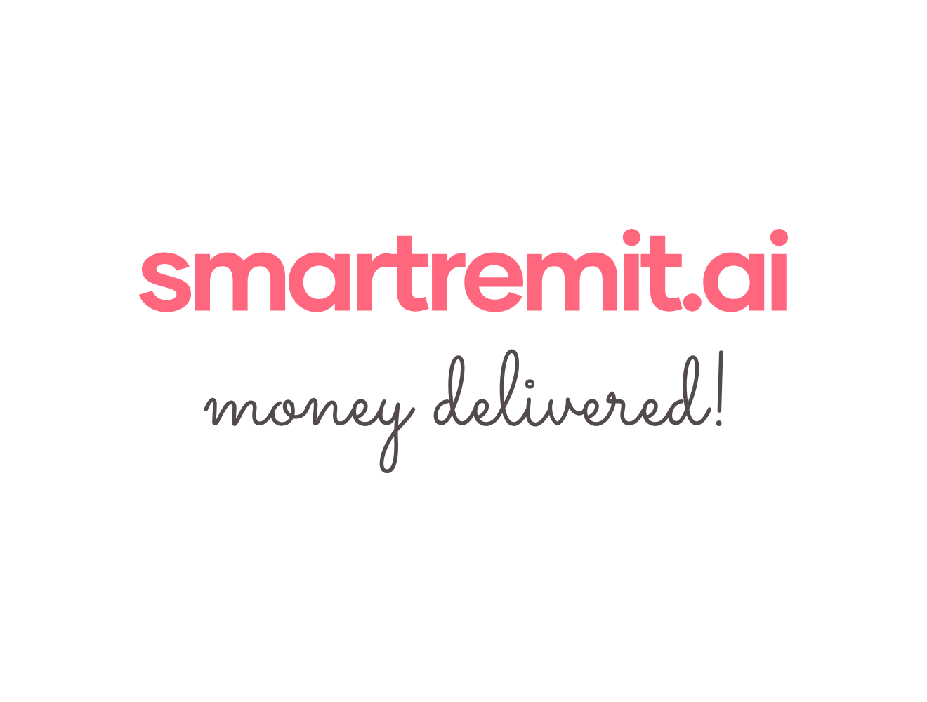SmartRemit AI Operations Runbook
1. Daily Checklist
Check | What to Review | Expected Result
Transaction volume | Number of transfers started, completed, failed, and on hold. | No unexpected spike or drop.
Stuck transfers | Transfers that remain in processing or in transit longer than expected. | No unresolved high-priority cases.
Compliance queue | Transfers held for review. | No old cases without action.
Partner API health | KYC, funding, FX, WhatsApp, and payout partner status. | No active outage affecting users.
Refunds and reversals | Refund cases created due to failed transfers. | All cases have a clear status.
Support tickets | User questions, failed transfers, and delayed status requests. | Users receive timely updates.

2. Exception Handling
Scenario | What the System Should Do | User Message Style
Incorrect recipient details | Hold or fail the transfer and ask the user to update details or request a refund. | Clear and helpful. Avoid technical language.
Insufficient funds | Cancel payment attempt and ask users to change funding source or lower amount. | Simple explanation with next step.
AML / compliance flag | Move transaction to review and prevent release until reviewed. | Generic regulatory review message. Do not reveal the exact reason for the flag.
Partner timeout | Check partner status again before marking failed. Avoid duplicate payout. | Tell user transfer is being checked and update will follow.
Payout failed | Check the reason, retry if safe, or initiate a refund according to policy. | Explain outcome and next step.

3. Escalation Guide
Issue | Escalation Action
Money movement issue | Pause action on the case and get technical and operations review before retry/refund.
Compliance hold | Send to compliance/legal review. Do not release funds without approval.
Data exposure risk | Stop related workflow, preserve logs, and escalate immediately.
Partner outage | Pause affected flow, notify users if needed, and monitor partner recovery.
Repeated user complaint | Create a support case with transaction ID, user message history, and current status.

4. Standard User Message Examples
Situation | Suggested Message
Transfer delayed | Your transfer is taking longer than expected. We are checking it and will update you shortly.
KYC under review | Your verification is under review. We will notify you once it is completed.
Recipient issue | The recipient details could not be verified. Please update the details or choose another recipient.
Refund started | Your refund has been initiated. We will share the final status once it is processed.

